

**AP Shop – Car parts Shop**

Version 1.0

November 13, 2022

Prepared by: Mak Alijević

For: AP Lab

Attn: Nerma Hanić

Copyright © 2016 by Authority Partners.  
All rights reserved.

This document contains proprietary, trade secret and/or confidential information of Authority Partners. This document cannot be reproduced in any manner, electronic or otherwise, published or distributed in any form and by any means without advance written consent of Authority Partners.

The Authority Partners logo is a trademark of Authority Partners.

All other product and company names mentioned herein are the trademarks or service marks of their respective owners.

**Table of Contents**

1 Purpose of this Document 6

2 Executive Summary 6

3 References 6

4 Requirements 6

4.1 User Stories 6

4.1.1 User Story <Title> 6

4.2 Use Cases 6

4.2.1 Use Case <Name> 7

5 Implementation solution 9

5.1 Overview 10

5.1.1 Design considirations 10

5.1.2 Key concepts 10

5.2 Architectural design 10

5.2.1 Overview of modules / components 10

5.2.2 Structure and relationships/dependencies 10

5.2.3 Physical arrangement of devices and Communication and installed software Components on devices 11

5.2.4 Architectural Styles/Patterns 11

5.2.5 Quality attributes/Non-Functional requirements 11

5.2.6 Crosscutting Concerns 11

5.3 Detailed design of components 11

5.3.1 Data Design 11

5.3.2 Component n-Detail (include a sub-section for each component) 11

5.3.3 Class diagrams 11

5.3.4 Sequence diagrams 11

5.3.5 Algorithm design 12

5.4 User interface 12

5.4.1 Interface Design Rules and guidlines 12

5.4.2 Detailed Description 12

5.4.3 Components available 12

5.5 Configuraiton notes 12

5.6 Testing guidelines 12

5.7 Deployment considirations 13

5.8 Requirements Not Addressed 13

# 1. Purpose of this Document

This document is the official documentation for AP Lab Project – AP Shop Web Application as a fully detailed guideline for design, development and implementation. CarGear Shop is an e-commerce we application that provides user ability to view and order car parts based on their needs and wishes. This document will serve as a detailed documentation regarding functional and non-functional requirements of the project.

# 2.Executive Summary

This document contains design, mockups, user backlog stories, plan of implementation, use case diagrams, activity diagrams and tech architecture.

# 3. References

AP-Shop – Personal project.docx

# 4. Requirements

This section contains appropriately detailed requirements.

## 4.1 User Stories

List of all user stories:

1. User story – verify logo position
2. User story – verify account icon position
3. User story – verify textbox search functionality
4. User story – verify categories dropdown functionality
5. User story – verify unregistered user functionality
6. User story – verify “Register” functionality
7. User story – verify “Login” functionality
8. User story – verify registered username position
9. User story – verify registered user “Search” functionality
10. User story – verify categories functionality
11. User story – verify sorting functionality
12. User story – verify filter functionality
13. User story – verify “Add product to cart” functionality
14. User story – verify cart functionality
15. User story – verify cart editing functionality
16. User story – verify “Buy now” functionality
17. User story – verify “Cash-out” functionality
18. User story – verify “Order history” functionality
19. User story – verify email on order functionality

### 4.1.1 User Story – verify logo position

As a User, I want to verify that logo is in the top left corner of the page so that it is always visible and clickable to all users.

Validated using:

* Navigate to Homepage or Products list page
* Verify that logo is in the top left corner in navbar
* Verify that logo is clickable (function: go back to Homepage)

### 4.1.2 User Story – verify account icon position

As a User, I want to verify that account icon is in the top right corner of the page so that it is always visible and clickable to all users.

Validated using:

* Navigate to Homepage or Products list page
* Verify that account icon is in the top right corner in navbar
* Verify that account icon is clickable
* Verify that dropdown contains options to login or register an account

### 4.1.3 User Story – verify textbox search functionality

As a User, I want to verify that textbox is in the middle of the Homepage so that it is always visible and clickable to all users on Homepage.

Validated using:

* Navigate to Homepage
* Verify that textbox is in the middle of the page
* Verify that textbox allows to enter text
* Verify upon entering search criteria I am forwarded to products list page with items listed according to my search criteria.

### 4.1.4 User Story – verify categories dropdown functionality

As a User, I want to verify that categories dropdown is placed next to search textbox on the Homepage so that it is always visible and clickable to all users.

Validated using:

* Navigate to Homepage
* Verify that categories dropdown is placed next to search textbox
* Verify that upon clicking on the dropdown I am provided with categories choice
* Verify upon clicking on category, the same category is selected
* Verify on search criteria only products from that category are listed

### 4.1.5 User Story – verify unregistered user functionality

As a User, I want to verify that logo is in the top left corner of the page so that it is always visible and clickable to all users.

Validated using:

* Navigate on Homepage or Products list
* Verify on account icon click, there are 2 options in dropdown (Login and Register)
* Verify on search, products presented don’t have buying and add to cart icons

### 4.1.6 User Story – verify “register” functionality

As a User, I want to verify that register button is available in account icon dropdown so that it is always visible and clickable to all users.

Validated using:

* Navigate to Homepage or Products list
* Verify on account icon click, there are 2 options in dropdown (Login and Register)
* Verify on register option click, modal is shown with necessary field for registering.

### 4.1.7 User Story – verify “login” functionality

As a User, I want to verify that login button is available in account icon dropdown so that it is always visible and clickable to all users.

Validated using:

* Navigate to Homepage or Products list
* Verify on account icon click, there are 2 options in dropdown (Login and Register)
* Verify on login option click, modal is shown with necessary field for logging in.

### 4.1.8 User Story – verify registered username position

As a User, I want to verify that my username is displayed in top right corner next to account icon so that it is always visible and clickable to logged user.

Validated using:

* Use login functionality to login
* Verify that upon logging in my username is displayed in top right corner next to account icon.
* Verify that my username is clickable and account options of logged user are available in dropdown.

### 4.1.9 User Story – verify registered user “search” functionality

As a User, I want to verify that search functionality is available so that it is always visible and clickable to logged in user.

Validated using:

* Use login functionality to login
* Verify upon logging Homepage or Products list is displayed
* Verify search textbox is visible to logged in user
* Verify after entering search criteria products list with desired products is displayed
* Verify that products displayed have “Buy now” and “Add to cart” options

### 4.1.10 User Story – verify categories functionality

As a User, I want to verify that categories functionality is available so that it is always visible and clickable to logged in user.

Validated using:

* Use login functionality to login
* Navigate to Products list page
* Verify that upon selecting one or multiple categories, products shown are only from those categories

### 4.1.11 User Story – verify sorting functionality

As a User, I want to verify that sorting functionality is available so that it is always visible and clickable to logged in user.

Validated using:

* Use login functionality to login
* Navigate to Products list page
* Verify that upon entering sorting criteria, products shown are sorted by that criteria.

### 4.1.12 User Story – verify filter functionality

As a User, I want to verify that filtering functionality is available so that it is always visible and clickable to logged in user.

Validated using:

* Use login functionality to login
* Navigate to Products list page
* Verify that upon filtering products with given filters, products shown are included within those filters and only those products are shown.

### 4.1.13 User Story – verify “add to cart” functionality

As a User, I want to verify that “Add to cart” functionality is available so that it is always visible and clickable within Products list page to logged in user.

Validated using:

* Use login functionality to login
* Navigate to Products list page
* Verify that upon entering search criteria, products shown have “Add to cart” button
* Verify upon clicking “Add to cart” button, the added product is stored in logged in users cart

### 4.1.14 User Story – verify cart functionality

As a User, I want to verify that cart icon is available and visible in the top right corner of navbar, next to account icon, so that it is always visible and clickable to logged in user.

Validated using:

* Use login functionality to login
* Navigate to Products list page
* Verify that upon clicking cart icon, modal with products stored in our cart is displayed showing our complete cart

### 4.1.15 User Story – verify cart editing functionality

As a User, I want to verify that cart editing functionality is available and so that it is always visible and clickable to logged in user.

Validated using:

* Use login functionality to login
* Navigate to Products list page
* Verify that upon clicking cart icon, modal with products stored in our cart is displayed showing our complete cart

### 4.1.16 User Story – verify “buy now” functionality

As a User, I want to verify that “Buy now” functionality is available so that it is always visible and clickable within Products list page to logged in user.

Validated using:

* Use login functionality to login
* Navigate to Products list page
* Verify that upon entering search criteria, products shown have “Buy now” button

### 4.1.17 User Story – verify “cash-out” functionality

As a User, I want to verify that “Cash-out” functionality is available and visible in the cart modal, below cart items list, so that it is always visible and clickable to logged in user.

Validated using:

* Use login functionality to login
* Navigate to Products list page
* Verify that upon clicking cart icon, modal with products stored in our cart is displayed showing our complete cart
* Verify that below cart items list “Cash-out” button is displayed
* Verify that upon click “Cash-out” button, user is navigated to cash-out page to confirm order
* Verify that upon confirming order, the order is placed, logged in user order history and the items are removed from cart

### 4.1.18 User Story – verify “order history” functionality

As a User, I want to verify that “Order history” functionality is available and visible in the account icon dropdown so that it is always visible and clickable to logged in user.

Validated using:

* Use login functionality to login
* Navigate to Products list page
* Verify that upon clicking account icon, dropdown will display “Order history” option.
* Verify upon clicking order history, the modal with complete user order history will be shown

### 4.1.19 User Story – verify email on order functionality

As a User, I want to verify that email functionality is functional so that user receives email confirmation with total price of the order on email he entered upon registering account.

Validated using:

* Use login functionality to login
* Navigate to Products list page
* Verify that upon clicking cash-out button, user receives mail with total price of order as a confirmation of his order

### 4.2.1 Use Case – Search products

#### 4.2.1.1 Summary

Use case diagram presenting process of users searching for product.

#### 4.2.1.2 Used By

Registered or Unregistered users.

#### 4.2.1.3 Pre-Conditions

User has navigated to Homepage or Products list page.

#### 4.2.1.4 Success End-Conditions

List of desired products is displayed in products list page with parameters user chose for the given search criteria.

#### 4.2.1.7 Acceptance Criteria

Acceptance criteria:

* User is navigated to products list page
* Items listed correspond to the given search criteria
* If user chose category, only items from the chosen category are displayed
* If user filtered the search, only items within those filters are displayed
* If user sorted the products listed the items are sorted by the chosen criteria

#### 4.2.1.8 Actors

User (Registered, Unregistered, Admin)

##### 4.2.1.8.1 Primary Actor

User (Registered, Unregistered, Admin)

### 4.2.2 Use Case – Buy products

#### 4.2.2.1 Summary

Use case diagram presenting process of users buying products.

#### 4.2.2.2 Used By

Registered users.

#### 4.2.2.3 Pre-Conditions

User is logged in.

User has navigated to the products list page.

#### 4.2.2.4 Success End-Conditions

An order for the product user bought is placed, the quantity in the database of the given product/products is decreased, and the order is stored in users order history.

#### 4.2.2.7 Acceptance Criteria

Acceptance criteria:

* Upon clicking on “Add to cart” the item with provided quantity is added to cart
* Upon clicking “Check-out” in the cart the user is navigated to the checkout page with the given cart items presented
* Upon clicking “Buy now” in the products page the user is navigated to the checkout page with that single item ready to be confirmed for order.
* After confirming order in the check-out page, the user is navigated back to home page and the order is placed.
* Quantity of selected product is decreased

#### 4.2.2.8 Actors

User (Registered)

##### 4.2.2.8.1 Primary Actor

User (Registered)

#### 4.2.2.9 Trigger

User clicks on “Buy Now” or “Add to Cart” button.

### 4.2.2 Use Case – admin modifying

#### 4.2.2.1 Summary

Use case diagram presenting process of admin users modifying (add, update, delete) products.

#### 4.2.2.2 Used By

Admin users.

#### 4.2.2.3 Pre-Conditions

User is logged in.

User has navigated to the products list page.

User is registered as an admin user.

#### 4.2.2.4 Success End-Conditions

After modifying desired products, the data in the database is changed fitting the admin data that has been entered.

#### 4.2.2.7 Acceptance Criteria

Acceptance criteria:

* User logged in has role of type “Admin” in the database
* “Add product” buttons are shown only for the admin user
* After clicking “Add product” button, admin is presented with necessary information to be stored about new product.
* In the Product Details modal the admin has 2 buttons that are only presented to him, “Modify item” or “Delete item”.
* After clicking “Modify Item” the modal with data about that item will be presented to him and admin will be available to change that data
* After clicking “Delete Item” the modal for confirmation of deletion will be presented. Upon confirming the selected item will be removed from the products list page (but not entirely from the database)

#### 4.2.2.8 Actors

User (Admin)

##### 4.2.2.8.1 Primary Actor

User (Admin)

# 5. Implementation solution

## 5.1 Overview

This project will consist of Angular-ASP.NET-MS SQL Tech Stack.

Frontend will be done using latest Angular version for SPA (Single Page Application).

Backend will be done using ASP.NET Core 6 and it will consist of 3 layered backend service. Lowest layer will be data access layer that will communicate directly with the database. Middle layer will be business logic layer and the top layer will be presentation / routes layer.

Database will be created using MS SQL Server.

## 5.2 Architectural design

### 5.2.1 Overview of modules / components

The application will be organized into 3 tiers. First tier is a single page application running in browser. Second tier is a .NET Core application which has several different layers with separate server functionalities. Third tier is a MS SQL database.

### 5.2.2 Structure and relationships/dependencies

### 5.2.3 Crosscutting Concerns

Rules and guidelines for crosscutting concerns such as instrumentation and logging, authentication, authorization, exception management, communication and caching.

## 5.3 Detailed design of components

### 5.3.1 Data Design

### 5.3.2 Class diagrams

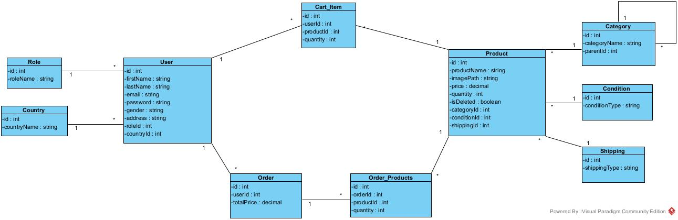

### 5.3.2 Activity diagrams

Activity diagrams:

* Activity – Buy products
* Activity – Admin modifying

#### 5.3.2.1 Activity – buy products

#### 5.3.2.2 Activity – admin modifying

## 5.4 User interface

User interface will be modern, easy and quick to use so that all users can navigate through pages with ease. Main theme will be black and white with car details and some red highlight colors. User interface will follow all necessary rules regarding user experience. AP Shop should provide detailed description of every product so that no vagueness is present while shopping online. Prices will be displayed in USD. All details user provides in the account registration won’t be publicly available except of logged in username.

#### 5.4.1.2 Guideline for error messages, warnings & supportive information

Any validation errors will be displayed as red highlighted areas.

Any errors regarding malfunctions will be displayed as toaster (JavaScript library) messages.

### 5.4.2 Detailed Description

1. Home page

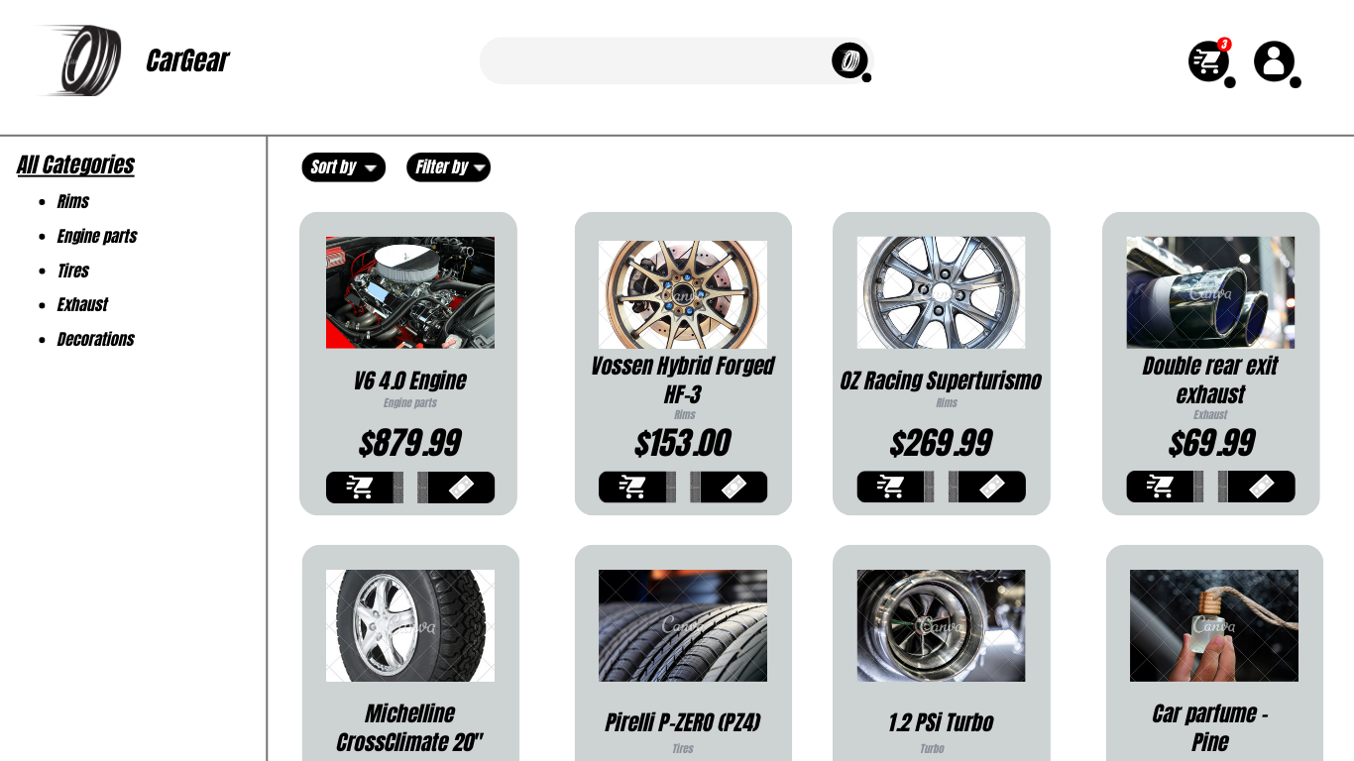

1. Products list page

1. Product details page

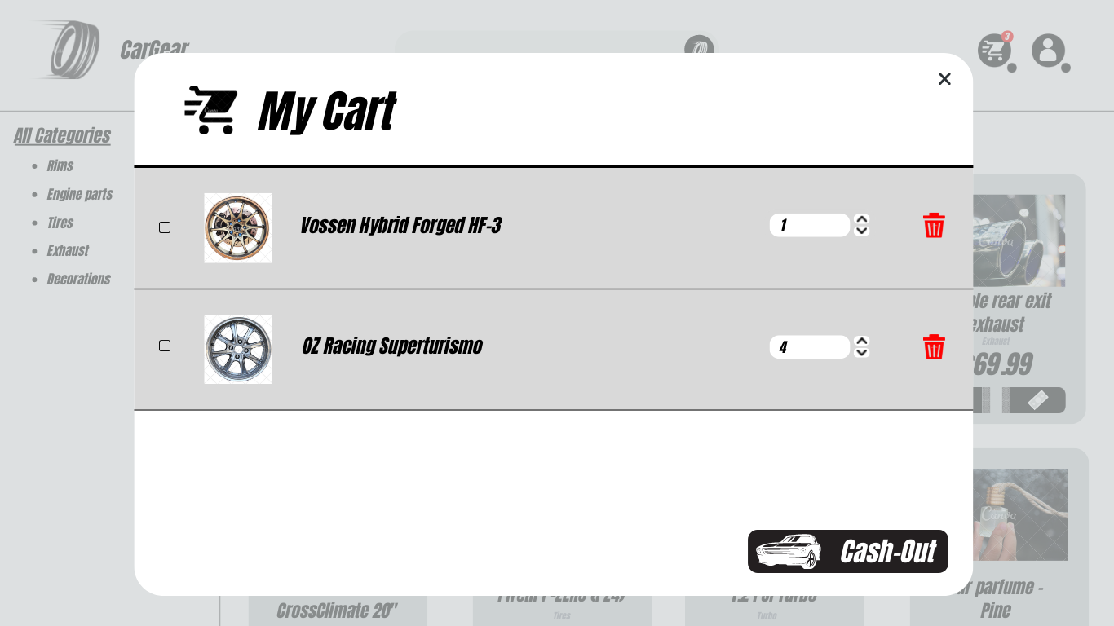

1. My Cart page

1. Cash-out page

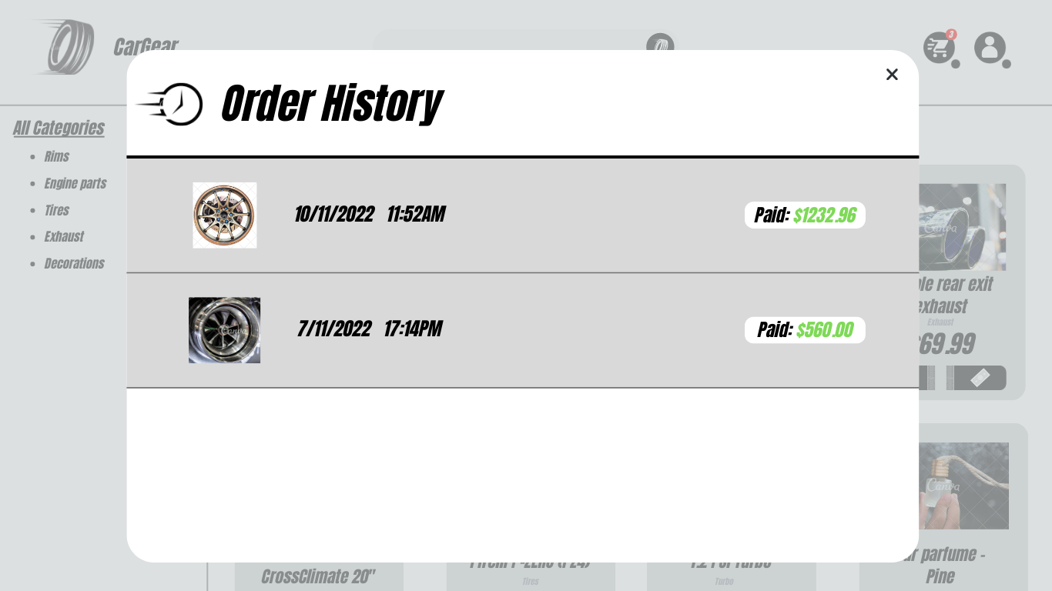

1. Order history page